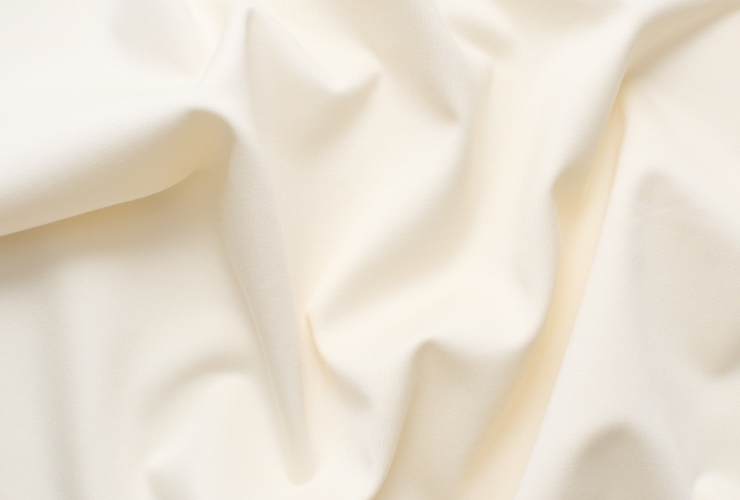Silkwood 2
Type: Curtain – Can also be used as light upholstery
Composition: 100% wool
Yarn type: Staple
Binding: Sateen
Width: Approx. 140 cm, 55 inches
Weight: Approx. 520 g/lin.m, 17 oz/ly
Repeat: None

Foreign fibers may occur in light colours
Colour difference may occur

Cleaning: Please see the ISO symbols
Disinfection, see kvadrat.dk
More info: Care and maintenance kvadrat.dk

Due to the composition of natural fibers the curtain can hang longer depending on the height of the curtain, room temperature and humidity.
This might also happen for textiles woven in a very open construction or knitted textiles.
It is therefore recommended to avoid the use of weight, but an adjustment of the length might still be needed after a while. Also, a possibility to let the curtain touch the ground when hanging.

gBCED
! u

Abrasion
Approx. 20.000 Martindale rubs, EN ISO 12947

Pilling
Note 4-5, EN ISO 12945

Seam slippage
Seam parallel to warp: 2.3 mm parallel to weft: 4.1 mm
EN ISO 13 936-2 180 Newton

Lightfastness
Note 3-7 ISO 105-B02

Fastness to rubbing
Dry note 4-5 ISO 105-X12
Wet note 4-5 ISO 105-X12

Flame resistance
AS/NZS 1530.3
NFPA 701 with treatment (AB 2998 compliant)

Only relevant when used as upholstery
BS 5852 Part 1
EN 1021-1/2

Free from added flame retardant chemicals as standard

Environmental benefits
Follow the EU Ecolabel dye restrictions incl. AZO dye
and heavy metal restrictions
REACH compliant
Californian Proposition 65 list compliant
LBC Red list compliant
Mono-material designed for circularity
Recyclable

Special recommendations
The curtain shall touch the floor, when hanging

Green building certificates
Greenguard Gold: Low chemical emission
Health Product Declaration (HPD): Declaring textile content and substance

Country of origin
United Kingdom

Warranty
2 years. See terms and conditions on kvadrat.dk

Kvadrat packaging and cardboard is recyclable. Cardboard material is FSC certified and / or contains recycled content.

For further information
kvadrat.dk

